**CMSC 636 – Data Visualization**

**Assignment 1 – Part 1 Tutorial**

Faisal Rasheed Khan

VB02734

[vb02734@umbc.edu](mailto:vb02734@umbc.edu)

**Dataset:**

Columns: 'aiddata_id', 'year', 'donor', 'recipient', 'commitment_amount_usd_constant', 'coalesced_purpose_code', 'coalesced_purpose_name'

**Tutorial Steps:**

**Step 1: Loading dataset into Tableau**

Download and install Tableau on your system[2]

On the top left as shown in the image above click on Data->Data Source or press ctrl+D, select appropriate file type and upload that file from your local drive, In my case its Excel sheet.

Go to the worksheet(bottom left) in order to start the data visualizations, you can create multiple worksheets, there are 3 icons at the bottom left: i. Creates new sheets, ii. Creates new dashboards, iii. Creates new story

This is how the layout looks like when we load a dataset, the columns of the dataset are under the Tables section (left).

Based on the column types the Showme(top-right) suggests the appropriate visualization. Marks are used to apply color, size, label, detail to the visualizations. Tooltip in the Marks shelf give the information when we hover the mouse. The filters shelf is used to filter the fields based on the condition provided.

**Step 2: Data Preprocessing**

Have checked for the null values in the dataset, but there aren’t any. For the tasks I am doing normalization and adding extra columns are not required.

**Step 3: Visualization for Vis/Task 1**

Our Vis/Task #1 is to visualize major donors and major recipients. For this we need Donor, Recipient and the Commitment Amount column to visualize.

Drag and drop all the required fields to the Maps shelf.

Select Color, size for the Commitment Amount field and select the treemap visualization. The view will be like this:

But the visualization is not appealing although the top donors and top recipients are visible, to make it more clean, need to apply filters.

We know United States is the top donor but it is not clear who is donating to whom and moreover Bilateral, unspecified is not the right one to show on the visualization, need to filter out that too.

The unspecified countries should be removed from the Recipient filter & we get rid of countries names which are not giving much information of the country.

To show who is donating to whom, need to append text before donating and recipient countries, by altering the Label in the Marks shelf.

Filtered out everything and altered all the changes, the final view is like this:

**Step 4: Visualization for Vis/Task 2**

Geospatial Visualizations of Donor and Recipient (Vis/Task #2):

The fields which are required for the visualization are donor, recipient and Commitment Amount. Add multiple repeated fields according to the criteria for example donor text, donor color- both are different. One displays name of donor and other displays unique color for distinct donors. In order to represent Geospatial on tableau, need to change the fields donor and recipient geographic roles to Country/Region

After doing the above step then apply Maps visualization from the Show Me(top right). The Receiver information is plotted on the map and the donor information and amount will be shown if we hover the mouse on a country

To add the donor plot on the map, need to drag and drop donor fields from the tables to the sheet, where Add a Marks Layer is visible, drop there an then donor marks are also visible along with the recipient plot on the map. Change the mark of the donor to square such that it looks unique.

In order to see top donors and top recipients on the map, need to filter out such that only major donations are visible otherwise clusters of donors will be there making visualization look bad. The donors are not correctly represented as the recipients have some unknown names in the dataset such as bilateral, unspecified and United States has more donations.

If we try filtering, then the recipient country’s amount of donations is not correctly represented as each recipient has more than one donor and the color palette is showing the minimum color amount. The representation of who donated more is mis leaded if we filter based on the Commitment Amount as there are unknown values in the map.

So, what to do is plotting the donors and recipient countries separately, such that both the maps have accurate data plotted. And then combine both the sheets using Dashboards.

Filter out the top 5 donors based on the Commitment amount field. Recipient filter is optional as we only focus on the correct major donors. Add text, colors to represent appropriately for the donor field.

The top donor countries are plotted:

Now need to work on the top recipient countries should be plotted on maps using the new sheet. Add the fields donors, recipients(text, size) and commitment amount(detail, color) to the marks shelf

Here filter based on the commitment amount such that only large amounts donors to the recipient countries are visible on the map. Filter out the unknown recipient countries name not recognized by the tableau such that real top recipient countries are visible on the map.

The legend of the Recipient needs to be sorted, the highest amount for the recipient is shown in bigger font and it will be in decreasing order.

Top Recipient countries who receive from donors:

Now create a dashboard to combine both the visualizations. Drag and drop both the sheets to the dashboard.

The final view is like this:

**Step 5: Adding Caption**

Tableau provides the caption option when we right click on the shelf section where filters, marks are there. It autogenerates the caption based on the visualization.

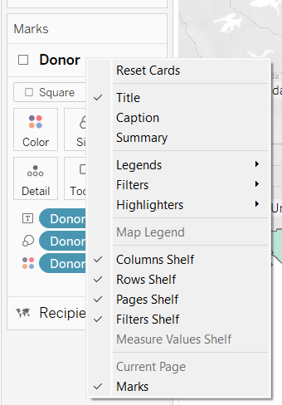

The autogenerated captions are not that effective, so I have written my own captions for the visualizations.

Vis/Task #1 Auto generated captions:

Vis/Task #2 Auto generated captions:

References:

[1] Tierney, Michael J., Daniel L. Nielson, Darren G. Hawkins, J. Timmons Roberts, Michael G. Findley, Ryan M. Powers, Bradley Parks, Sven E. Wilson, and Robert L. Hicks. 2011. More Dollars than Sense: Refining Our Knowledge of Development Finance Using AidData. World Development 39 (11): 1891-1906

[2] Tableau

https://public.tableau.com/app/profile/nir.smilga/viz/TableauPublicExplorer/TableauPublicExplorer